Skip to Main Content

[This site was designed with the](https://www.wix.com/lpviral/enviral?utm_campaign=vir_wixad_live&adsVersion=white&orig_msid=b8711c73-f667-413d-ad4f-e2588ecbc50e" \t "_blank)

[.com](https://www.wix.com/lpviral/enviral?utm_campaign=vir_wixad_live&adsVersion=white&orig_msid=b8711c73-f667-413d-ad4f-e2588ecbc50e" \t "_blank)

[website builder. Create your website today.Start Now](https://www.wix.com/lpviral/enviral?utm_campaign=vir_wixad_live&adsVersion=white&orig_msid=b8711c73-f667-413d-ad4f-e2588ecbc50e" \t "_blank)

[](https://b8711c73-f667-413d-ad4f-e2588ecbc50e.filesusr.com/ugd/c98d81_813bb0459ac042bdb30eeaf5402a7925.pdf)

**“Whoever is generous to the poor lends to the lord, and he will repay him for his deed.”**



**MY SONG**

**“BELIEVE EVERYTHING IS POSSIBLE IN JESUS CHRIST**

**I AM THE CHILD OF JESUS CHRIST LIVING WITH MY BELOVED FATHER MOTHER CHILDREN SISTERS BROTHERS BELOVED ONES FAMILY IN JESUS CHRIST WITH JESUS CHRIST WITH HIS GOOD WORKS IN ME**[**https://istheonlywayjesusc.wixsite.com/love**](https://istheonlywayjesusc.wixsite.com/love)

**FOREVER PHYSICALLY ETERNALLY HEAVENLY IN IMMORTALITY RAISED RESURRECTED INCARNATED ALL GENERATIONS**

**JESUS IS MY HERO**

**JESUS IS MY SAVIOUR**

**JESUS IS MY HOME**

**I LOVE YOU JESUS CHRIST UNCONDITIONALLY BY BOWING DOWN MY HEAD BEFORE YOU AND SERVING YOU ONLY CAUSE MY JOB IS DONE THAT NO ONE ELSE COULD HAVE DONE EVEN IN DREAMS SO MY ROLE ENDS HERE AND NOW I AM IN DREAMS OF ETERNAL LIFE LIVING IN JESUS”**

**by Pastor Paul Eliya**[**https://pauleliya853.wixsite.com/love-live-with**](https://pauleliya853.wixsite.com/love-live-with)

[**https://istheonlywayjesusc.wixsite.com/jesuschrist**](https://istheonlywayjesusc.wixsite.com/love)

**JOIN US AIRFORCE**[**https://www.af.mil/**](https://www.af.mil/)

**I CAN BECOME THE PRESIDENT OF THE BELOVED UNITED STATES OF AMERICA IF JESUS WANTS IT FOR ME IT WILL BE DONE SOON I HOPE IN FAITH AND IN EVERLASTING LOVE AND I AM THE ONLY BEST FIGHTER PILOT OF THE US AIR FORCE BECAUSE I AM MORE THAN YOU BELIEVE IN ME BECAUSE I AM THE TIME TRAVELLER IN THE COLOURFUL UNIVERSES STARS PLANETS I FLY AND LIVE AMONG THEM WITH MY ONLY HOLY FATHER JESUS CHRIST ALONG WITH MY BELOVED AND BELONGINGS ALONG WITH MY GOOD WORKS OF MY SOUL OF JESUS CHRIST BY LOVING JESUS CHRIST UNCONDITIONALLY. MUST DOWNLOAD ALL MY ATTACHMENTS AND READ IT AND SAVE IT IN YOUR SOULS**



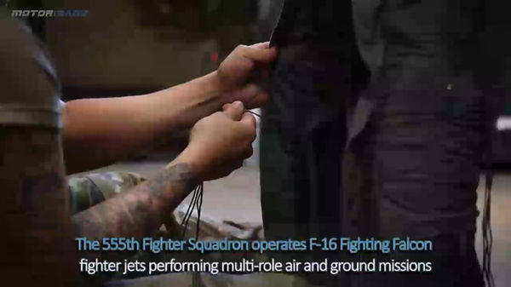



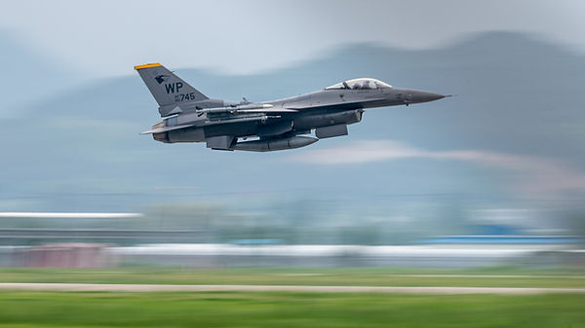



[+](https://b8711c73-f667-413d-ad4f-e2588ecbc50e.filesusr.com/ugd/ab9c7d_2fcbf008d7474130a33d51ab0b2ab77a.xlsx?dn=FIRST%20TALENT%20OF%20INDIA.xlsx" \t "_blank)

[1](https://b8711c73-f667-413d-ad4f-e2588ecbc50e.filesusr.com/ugd/ab9c7d_ce45ae5d1761435193625ff534ec7320.pdf" \t "_blank)

[-](https://b8711c73-f667-413d-ad4f-e2588ecbc50e.filesusr.com/ugd/ab9c7d_b1ba954d93924738937608afe63debbe.pdf" \t "_blank)

[4](https://b8711c73-f667-413d-ad4f-e2588ecbc50e.filesusr.com/ugd/ab9c7d_7aebce1e198e49d78bfeee8272343be5.pdf" \t "_blank)

[.](https://b8711c73-f667-413d-ad4f-e2588ecbc50e.filesusr.com/ugd/c98d81_9393185b22e24a7f99fe35bb93ee1c12.pdf" \t "_blank)

[7](https://b8711c73-f667-413d-ad4f-e2588ecbc50e.filesusr.com/ugd/ab9c7d_4b6504d0aa9844d39e4a65b80e415b18.pdf" \t "_blank)

[N\*10^N](https://b8711c73-f667-413d-ad4f-e2588ecbc50e.filesusr.com/ugd/c98d81_e800c7a6f39c401fadc0181828dce542.docx?dn=JESUS%20CHRIST%20IS%20THE%20ONLY%20WAY.docx" \t "_blank)

[2](https://b8711c73-f667-413d-ad4f-e2588ecbc50e.filesusr.com/ugd/ab9c7d_1533a51f8c5b49f39c84a3f40daf2717.pdf" \t "_blank)

[5](https://b8711c73-f667-413d-ad4f-e2588ecbc50e.filesusr.com/ugd/ab9c7d_85c2926786ed4402ba60d1dc0e657c15.pdf" \t "_blank)

[8](https://b8711c73-f667-413d-ad4f-e2588ecbc50e.filesusr.com/ugd/ab9c7d_cc1f09df178f45c39bc6112b2a5de78b.pdf" \t "_blank)

[0](https://b8711c73-f667-413d-ad4f-e2588ecbc50e.filesusr.com/ugd/c98d81_813bb0459ac042bdb30eeaf5402a7925.pdf" \t "_blank)

[3](https://b8711c73-f667-413d-ad4f-e2588ecbc50e.filesusr.com/ugd/ab9c7d_aec1f68145814f64a3b9ed4141fc836a.pdf" \t "_blank)

[\*](https://b8711c73-f667-413d-ad4f-e2588ecbc50e.filesusr.com/ugd/ab9c7d_c7c0a2bc3aea48a2a6a5b448781a912b.pdf" \t "_blank)

[6](https://b8711c73-f667-413d-ad4f-e2588ecbc50e.filesusr.com/ugd/ab9c7d_34cccc067bf24fa0bc2ee087e6b77208.docx?dn=NINTH%20TALENT%20OF%20INDIA.docx" \t "_blank)

[/](https://b8711c73-f667-413d-ad4f-e2588ecbc50e.filesusr.com/ugd/ab9c7d_28feafa3a8d845cd9cdc73ff6471104d.pdf" \t "_blank)

[9](https://b8711c73-f667-413d-ad4f-e2588ecbc50e.filesusr.com/ugd/ab9c7d_082c7b1bbca640978a20855457caef09.docx?dn=FIGHTER%20PILOT%20PAUL%20ELIYA.docx" \t "_blank)

[AP](https://b8711c73-f667-413d-ad4f-e2588ecbc50e.filesusr.com/ugd/c98d81_8daea166ab63443da7c6700311b64ef8.docx?dn=BLASPHEMY%20CASE.docx" \t "_blank)

[NS](https://b8711c73-f667-413d-ad4f-e2588ecbc50e.filesusr.com/ugd/ab9c7d_efb95ed7bce44a048076027904b45abb.pdf" \t "_blank)

United States of America National Anthem Instrumental

00:00 / 01:18

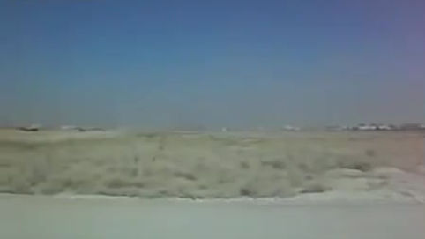

[EW](https://b8711c73-f667-413d-ad4f-e2588ecbc50e.filesusr.com/ugd/ab9c7d_efb95ed7bce44a048076027904b45abb.pdf" \t "_blank)

[GPS AI](https://b8711c73-f667-413d-ad4f-e2588ecbc50e.filesusr.com/ugd/c98d81_d67eb70b3daa49c89bf908eba4acfee8.pdf" \t "_blank)







[[](https://istheonlywayjesusc.wixsite.com/jesuschrist)](https://istheonlywayjesusc.wixsite.com/jesuschrist" \o "Apple" \t "_blank)

[[](https://istheonlywayjesusc.wixsite.com/jesuschrist)](https://istheonlywayjesusc.wixsite.com/jesuschrist" \o "Apple" \t "_blank)

[[](https://istheonlywayjesusc.wixsite.com/jesuschrist)](https://istheonlywayjesusc.wixsite.com/jesuschrist" \o "Apple" \t "_blank)

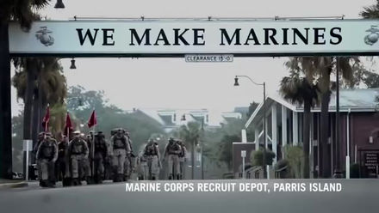



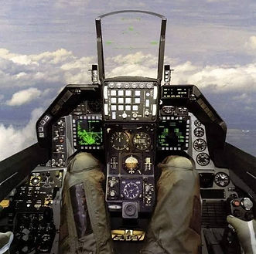













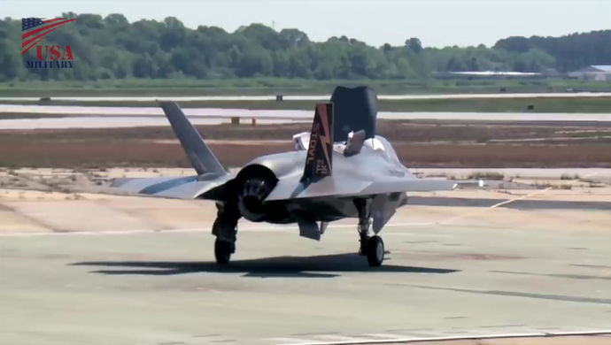

[**BATTLEMAN**](http://istheonlywayjesusc.wixsite.com/LOVE)

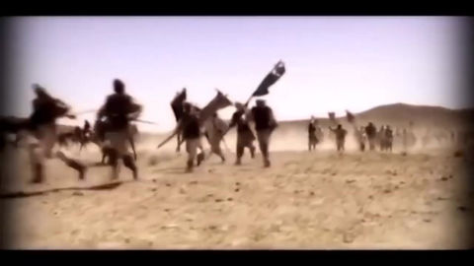

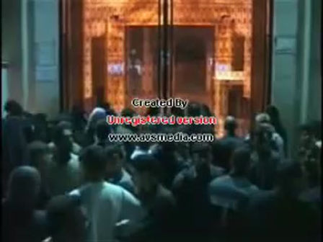

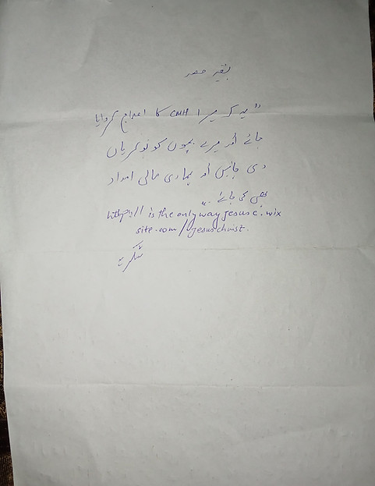

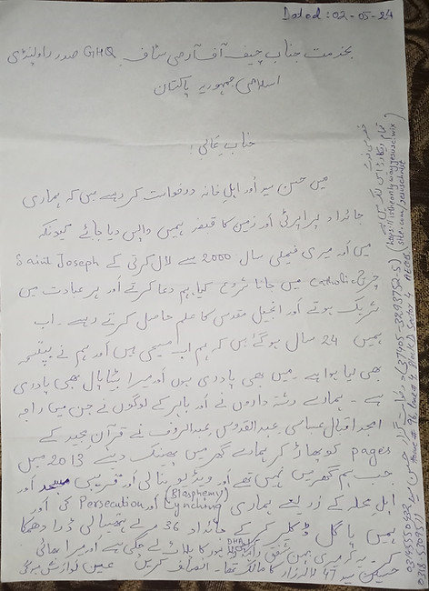

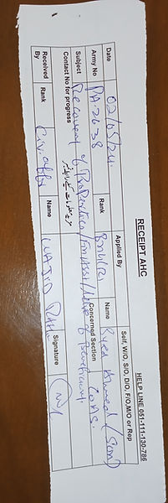

**Dear Shmyla Khan**

**Researcher and Campaigner – Pakistan**

**South Asia Regional Office (SARO)**

**Mobile (WhatsApp and Signal): +92 0322 404 2588**[**shmyla.khan@amnesty.org**](mailto:shmyla.khan@amnesty.org)

**I Paul Eliya Son of Hassan Syed(Henry Lawrence) and Family requests the Letter of Recommendation from Amnesty International NGOs for our Immediate Refuge Asylum in any safe Country of the World IF THIS CASE COMES IN YOUR JURISDICTION, AMBIT, ROLE, LAW, RULES, REGULATIONS AND POLICIES FOR PROTECTING HUMAN BEINGS AND THEIR FUNDAMENTAL HUMAN RIGHTS UNCONDITIONALLY**

**Thank you for your email**

**My family and I have been Experiencing a Systematic Persecution since 24 years I have also informed Pakistan Army 408 Intelligence Battalion regarding this precarious and Horrible situation, in Pakistan if anyone even said verbally only that this man has committed Blasphemy the whole Public gathers and kill that man without any proof or investigation the Pakistani Greedy Illiterate Suni Muslims Raja Amjad Iqbal Abbasi Abdul Qudoos, and Abdul Rauf and Relatives stolen our Property House Our Catholic Church#CB-3650(25-A) Lane#5-A Lalazar Colony because we regularly and daily Pray Worship in our Home and we made it Church but Neighbors and Relatives were not happy with our Unconditional Love Sincerity with our Lord Jesus Christ so the people of Tulsa Road Lalazar Colony Rawalpindi Cantt thrown us out of our Property by accusing us for doing Blasphemy against Holy Quran Islam and Holy prophet but I don't know exactly where and what kind of Hidden cases of Blasphemy are still pending against us for example 295-A crPC, 295-B crPC and 295-C crPC u/s 154 crPC in the Police stations courts of law of Pakistan in Rawalpindi and Islamabad and I appeared before Islamabad High Court and before Islamabad District and Sessions Court regarding Blasphemy Allegations in year 2022 and got Locked up for 24 hours in Police Station Kohsar on 17-02-2021 for preaching Holy Bible and Protesting for Justice me and my mother were jailed for 1 Day and were released after 24 hours, the Islamabad Police Cutted my Left hand wrist to Declare Suicide and hit my head with the Walls of Lock up jail 6 Times so hard that my Head start Bleeding and sound of my head can be heard even I was unconscious and one Police officer Took his Revolver and put it on my Head and he was about to pull the Trigger and I was unconscious and they did not took me to hospital PIMS or Poly Clinic and handcuffed me with the chair of the SHO Room but Lord Jesus Saved me because Jesus Said Be Faithful unto Death and I shall give you the Crown of Life.**

**we have shifted 28 houses in 8 years because Suni Majority Neighbors in Lalazar Colony and Tulsa Road Lane #5-A Accuses me and my family for Burning Quran and Tearing the Pages of Holy Book Quran and Desecration of Quran and we were forced to leave our house and they Threatened us with Mob Lynching that if we do not sign and thumb impression the transfer papers of our house the Mob will kill us and we will be assassinated by unknown and they Harrased us by stopping our basic utilities and aminities for our survival and now we are secretly hiding in Rawalpindi however The Suni Mindset Jihadi Extremists in Defence Military Authorities And in Security Agencies and in Government Kidnapped my father and threatened us that they will not let us Escape from Pakistan further they framed us as mad mentally unstable persons family to persecute us systematically due to their religious hatred against Christians.**

**I cannot get a job because where ever I go intelligence agencies warns the Employers not to give job or financial help at any cost even they also deprived me from getting Higher Education and they Hijacked our Fundamental Human Rights and In order to protect our lives I start using Social Media**

[**https://istheonlywayjesusc.wixsite.com/jesuschrist**](https://istheonlywayjesusc.wixsite.com/jesuschrist)

**against the ISIS Jihadi Daishi Suni Deobandi Barelvi Illiterate Murderers Terrorists Criminals in Mosques Madrasas In Rawalpindi**

**me and my family are Vulnerable Christians Facing Persecution and Mob Lynching through Blasphemy Laws of the Islamic Republic of Pakistan and facing a Direct Threat from Mobs People in Pakistan**

**I'm writing to urgently request your help and support for my family and me. We're a persecuted Christian minority in Pakistan, facing imminent danger and threats from extremist groups. We've lost our assets, and our lives are at risk.**

**We desperately need your assistance to:**

**1. Provide financial support for our survival and relocation.**

**2. Facilitate our extraction from Pakistan and resettlement in a safe country (Europe, Canada, Australia, or Scandinavia).**

**We're seeking help on humanitarian and religious grounds. Any assistance would be a blessing.**

**Please, please help us escape this hell. We're running out of time.**

**Thank you for considering our plea.**

**I will keep following up my Request on Humanitarian Grounds**

**Please send necessary Help**

**Sincerely,**

**Pastor Paul Eliya Son of Pastor Henry Lawrence and family**

**Our Current Address is House#96, lane#4, block D, sector 4,Airport Housing Society Rawalpindi Cantt**

**Our Contact# +92-314-555-0432**

**And +92-318-530-9511**

**I have the 500 GB Complete Record Proof Evidences of Persecution are in my this website below and I have the Physical Documents of Courts Police Stations Complaints against The Culprits**

**My Online Salvation Church is**[**https://istheonlywayjesusc.wixsite.com/jesuschrist**](https://istheonlywayjesusc.wixsite.com/jesuschrist)

**Jesus Christ will give us Justice**

**Because we are the Obedient Children of our Lord Jesus Christ, we Bow Down Our Heads Before our only Saviour Son of God Jesus Christ who lives in our Souls Minds Hearts**

**Please Follow up through this Email address**[**henrylawrence7212@gmail.com**](mailto:henrylawrence7212@gmail.com)

**​**

**During Rapture Lord Jesus Christ will come from Heaven and Call his children believers followers from airs sands muds waters earth space who only bodily died but not spiritually and those who are still Alive will be all raised above and will meet the lord Jesus Christ in the Air and Jesus Christ will hold our Hands and will take us with him along with our beloved ones all family generations along with our Good works**[**https://istheonlywayjesusc.wixsite.com/love**](https://istheonlywayjesusc.wixsite.com/love)**along with our belongings with everything impossible for us but possible for The Holy Son of God Jesus Christ we ask for in prayer believe that we have received it and it will be ours on the Right Hand Side of God.**

**me my family are Vulnerable Baptized Christians trying to Survive since year 2000 but in 2014 Raja Amjad Iqbal Abbasi Abdul qudoos Abdul Rauf Ahle Mohalla Suni Barelvi Masjid Madrasa Mob Gathered and tried Lynching us to Death they attempted to Burn me and my family alive while we were sleeping they entered our house and they shed Petrol in our house and all the room connected to the other was blacked and burned but fire did not entered our room in year 2004 when we were small kids,in 2014 they Accuses me my family for Buring Quran Tearing its Pages stepping on it, they harrased us threatened us to leave my house or they will kill us through Mob Lynching by Accusing me for committing Blasphemy against Prophet Muhammad and against his Quran Islam Hadees Companions and filed a Verbal FIR 295A 295B 295C against me forcibly took our signatures thumb impressions on the Sale Deed if we do not do it they will kill us, complete details of incidents of Persecution Evidences are in this website**[**https://istheonlywayjesusc.wixsite.com/Salvation-church**](https://istheonlywayjesusc.wixsite.com/Salvation-church)

**Some Fake Christians poisoned my food twice and I get critically illed but recovered and I live on footpath roads**

**I am using my family's phone to send this Email but No NGO in the World is helping me**

**COAS Pak Army is requested to recover Property#CB3650 25A 36 Marlas lane 5A Lalazar,Arrest this Gang operating in Pakistan targeting Christians for their greed for christians's Properties damaging Good Nature of Pakistan This Gang is ISIS.**

**My case is Similar to Assia BIBI, jaranwala sargodah case**

**Punjab Police IG Sent Complaint# 219734 Sindh Police CNIC# 37405-0365980-9**

[**https://youtu.be/lFoxjm5mmhA?si=\_jShDev87gDp3biz**](https://youtu.be/lFoxjm5mmhA?si=_jShDev87gDp3biz)

[**https://youtu.be/hWX3\_duqAWk?si=Vu8TdJollRpXaI4L**](https://youtu.be/hWX3_duqAWk?si=Vu8TdJollRpXaI4L)

[**https://youtu.be/wgWWfe7fi98?si=n7ilzQn-YiGCN4yh**](https://youtu.be/wgWWfe7fi98?si=n7ilzQn-YiGCN4yh)

**The Beloved Brave Courageous Knowledgeable Pakistan Army Attacked My Enemies and Open Fire with AK-47 on Islamabad Police Thana kohsar and gave them a lesson for a lifetime for locking me up in Jail, but I Killed Islamabad Police Both Men and Women Soully Spiritually through my Courage Knowledge Talent of my Soul Physically.**

**Coding and Decoding Assets Matter Masses with Radiation virus Detection and please press all the Buttons to Educate Yourself**

**THESE COUNTRIES MUST BE BOMBED BECAUSE THESE COUNTRIES ARE NOT STOPPING IN SUPPORTING THE  
UNFORGIVABLE AND UNFORGETTABLE DEEDS OF LANTI HOMOSEXUALS ADULTERERS MURDERERS ABUBAKAR UMER  
USMAN AISHA MUAWIYA YAZEED SHIMMAR ABDUL REHMAN SADDAM HUSSAIN OSAMA BIN LADEN ABUBAKAR ALBAGHDADI  
HAFIZ SAEED AND THEIR SUNI QURAN HADEES ISLAM MINDSET AND THEIR GENERATIONS AND THEIR CAUSES ARE  
DESTROYED THROUGH THIS WEBSITE**[**https://eliyasyedaliabbasp.wixsite.com/love-serve-protect**](https://eliyasyedaliabbasp.wixsite.com/love-serve-protect)**MY MISSION IS  
ACCOMPLISHED ACTUALLY, BELOVED ISRAEL DID THE RIGHT THING BECAUSE HAZBULLAH HOUTHIES ARE ANTI-BAAP ALI  
SO IRAN WILL BE RESPONSIBLE FOR ANYTHING BAD HAPPENING TO IRAN ALWAYS REMEMBER THE GOOD LADY MOTHER  
OF MARHAB HARRIS AND ANTER TOLD THEIR SONS NOT TO FIGHT WITH BAAP ALI THE HAIDER BECAUSE HE IS OUR MASTER  
OUR LORD OUR LEADER SON OF ABRAHAM AND GRANDSON OF KING DAVID BUT MARHAB AND HIS BROTHERS WENT  
AGAINST THEIR RELIGION AGAINST THE OLD TESTAMENT AND THEY GO AGAINST THE NEW TESTAMENT AND AGAINST THEIR  
MOTHER AND GET KILLED ON ACCOUNT OF BEING ANTI ALI SO ANYONE WHO IS  
ANTI-**[**https://eliyasyedaliabbasp.wixsite.com/love-serve-protect**](https://eliyasyedaliabbasp.wixsite.com/love-serve-protect)**IS ACTUALLY ANTI ALI BECAUSE BAAP ALI WAS A JEW THAT IS  
WHY PEOPLE PRAY DAROOD E IBRAHIMI THATS IS WHY HE BAAP ALI HELPED JEWS AND BAAP ALI NEVER FOUGHT AGAINST  
JEWS CHRISTIANS HINDUS SIKHS JAINS PARSI BHUDDISTS BUT HE FOUGHT AGAINST KAFIR MUNAFIQ MUSHRIQ MUSLIMS OF  
THAT TIME AND TILL NOW HE IS FIGHTING THROUGH THIS WEBSITE ONLY ETERNAL MATTER SOUL SILICON H2O LIGHT  
PARTICLE ELECTROMAGNETIC RADIATION ENERGY PHYSICALLY FEELING & SEEING ALI BEING THE HOLY FATHER I AM RAM  
SYED I AM ABRAHAM SYED I AM DAVID SYED I AM MOSSES SYED I AM JESUS CHRIST SYED I AM GURU NANAK SYED I AM  
MUHAMMAD SYED I AM BAAP ALI SYED I AM FATIMA SYED I AM HASSAN SYED I AM HUSSAIN SYED I AM ZAINAB SYED I AM  
QULSUM SYED I AM MOHSIN SYED I AM ABBAS SYED I AM LOVE FAITH HOPE**[**https://eliyasyedaliabbasp.wixsite.com/jai-shri-ram**](https://eliyasyedaliabbasp.wixsite.com/jai-shri-ram)**I AM A SANATANI HINDU SIKH CHRISTIAN JEW CHILD only I also want to  
marry a Christian Lady or Jewish Girl of age 26 years old and I want to Join US or Indian Army I want to Become  
IAF Indian Airforce F-16 Rafale Miraj Tejas Navy Fighter Pilot and I want to Join RAW. I am the Child of Jesus Christ living with my  
Beloved Holy Fatherly Natured Father Mother children sisters brothers family with Jesus Christ Forever with Good works**[**eliyasyedaliabbasp.wixsite.com/love**](http://eliyasyedaliabbasp.wixsite.com/love)**I have Done Physically Eternally Heavenly in immortality raised resurrected incarnated all  
generations Jesus is my Hero Jesus is my Home Jesus is my Saviour Jesus Saves my Good Works of 5 GB in The Museum of  
New Jerusalem and Take us all to his Eternal Kingdom and Jesus Christ Saved my Good Works in My Soul Amen I PAUL ELIYA and my family IS AN EX-MUSLIM since 24 Years AND THE SOUL SON  
OF GOD JESUS CHRIST SENT ME TO AWAKE THE WORLD IF ANY HUMAN BEING HURTS OTHER HUMANS THEN THAT HUMAN  
BEING WILL BE BROUGHT TO JUSTICE OF HUMANS BEINGS AND ANY HUMAN BEING CAN BE A FAKE SHIA MUSLIM OR CAN  
BE A FAKE SIKH OR CAN BE A FAKE HINDU OR CAN BE A FAKE CHRISTIAN OR CAN BE A FAKE JEW OR CAN BE ANY FAKE  
PERSON BUTCAA AND NRC HAS EXPOSED THESE FAKE PEOPLE WHO ARE THE REAL FOLLOWERS OF LANTI ABUBAKAR  
UMER USMAN AISHA MUAWIYA ABDUL REHMAN YAZEED SHIMMAR IBNE JOSHAN etcSO THEIR FOLLOWERS MUST BE  
THROWN OUT OF INDIA TO THE COUNTRY OF THEIR RELIGION MINDSET IN ORDER TO PROTECT HOLY HINDU SIKH CHRISTIAN  
JEWS MUSLIMS CHILDREN WOMEN MENTHIS IS THE ONLY SOLUTION SO ALL THE COUNTRIES OF THE WORLD MUST BRING IN  
CAA TO TAKE IN WANTED REFUGEES AND NRC TO THROW OUT UNWANTED REFUGEES IN THE BEST INTEREST OF THE  
NATIONAL SECURITY OF THEIR COUNTRIES FOR GOOD SECULARISM IS ONLY APPLICABLE IN THOSE COUNTRIES WHERE  
PEOPLE LOVE ONE ANOTHER AND FOLLOWS ME VIA MY THESE TWO  
WEBSITEShttps://**[**eliyasyedaliabbasp.wixsite.com/lovehttps://eliyasyedaliabbasp.wixsite.com/paulTHE**](http://eliyasyedaliabbasp.wixsite.com/lovehttps:/eliyasyedaliabbasp.wixsite.com/paulTHE)**SOUL IS AN ETERNAL  
MASS THAT CAN NEVER BE CREATED NOR DESTROYED NEITHER IN HEAVEN NOR IN HELL BUT IT CAN CHANGE FROM ONE  
SPIRITUAL FORM ENERGY TO ANOTHER PHYSICAL FORM ENERGY TRUE LIFE STARTS WHEN EYES ARE CLOSED AND WE  
SEE HEAVENS WHEN JESUS CHRIST GIVES US ETERNAL LIFE IN HIS ETERNAL KINGDOM AND HIS RIGHTEOUSNESS AND ALL  
THE THINGS ARE ADDED UNTO US AND MUCH MORE**[**https://youtu.be/-31JX2XEi9g?si=AyEQyoWCFR0ihzP0**](https://youtu.be/-31JX2XEi9g?si=AyEQyoWCFR0ihzP0)[**https://youtu.be/8DMF0U6xV78?si=JnnJDox5OYRJSGc0**](https://youtu.be/8DMF0U6xV78?si=JnnJDox5OYRJSGc0)[**https://youtu.be/ws\_QOR4FVuY?si=JP6azg-dmF6YAvl8**](https://youtu.be/ws_QOR4FVuY?si=JP6azg-dmF6YAvl8)[**https://youtu.be/2usqn31-ew4?si=A-DI9bdRX-HiPctQ**](https://youtu.be/2usqn31-ew4?si=A-DI9bdRX-HiPctQ)[**https://youtu.be/EblY786RqFE?si=SYvAmkavhqcuUSIX**](https://youtu.be/EblY786RqFE?si=SYvAmkavhqcuUSIX)**IN THE NAME OF THE  
HOLY FATHER THE HOLY SON AND THE HOLY SPIRIT GOD BLESS ALL THE WORLD THE WAGES OF UNFORGIVABLE SIN IS NOT  
ONLY THE DEATH OF HUMAN BODY BUT ALSO THE DEATH OF THE SOUL.DEATH LOOKS LIKE THAT WE ARE SLEEPING BUT  
WHEN WE ARE AWAKE WE HAVE A PHYSICAL ETERNAL LIFE FOREVER ALONG WITH OUR BELOVED ONES AND OUR GOOD  
WORKS IN HEAVEN BUT IN CASE OF BAD PEOPLE THERE IS AN ETERNAL HELL FIRE WAITINGInstead of Killing Enemies, only  
their Mindsets must be killed by Freeing them by Educating them by making them understand by differentiating between Right and  
Wrong logically Historically Faithfully by Judging between Right and Wrong By Every means by making their Intentions Good by  
Loving them by changing their Hearts by Unconditionally Loving them protecting them serving them by giving them their all  
Fundamental Human Rights and this could be done easily and it is possible,so by changing their Mindsets and making them  
realize who what when where why through Deep Thinking by correcting their Faith Quran Hadees etc in the interest of all Human  
Beings by Educating their Human Generations Only Those MUSLIMS must be killed who have done unforgivable  
crimes(sins)Against Any Human Being in the WorldBecause there is a Limit of Everything So Unconditionally Love Serve Worship  
Jesus Christ by Bowing Down your Head Before Lord Jesus Christ by Unconditionally Loving Serving and Protecting his Hindu  
Sikh Jewish Muslims Christians Children Women Men of Jesus Christ by Believing in Him for His Incarnation Resurrection and  
Coming back and taking us to his Eternal life kingdom along with our beloved ones family and along with our good works and our  
belongings physically Eternally Heavenly in immortality in the New Jerusalem So Believe in The Incarnation of the Lord and Accept  
the Soul Spirit Son of God Jesus Christ and His Blood in Your Life due to the Miracles and Good Works of Jesus Christ because  
Jesus Christ is Eternal life because no human being can perform these miracles as Done by Lord Jesus Christ When I Strongly  
Felt Baap Ali for being the Holy Father of Hassan Hussain Zainab Qulsum Mohsin Abbas and I See Baap Ali for being the Soul of  
Hassan Hussain Zainab Qulsum Mohsin Abbas and I Felt And See Ali For Being The Love Loving Husband Of Fatima Zahra  
Alaisalaam and What Ali Said about Fatima Zahra is A Flower Came from Heaven went to Heaven and Left its Fragrance in My Mind  
and Ali for being The Holy Father Fatima being the Holy Mother and Their Children are The Soul of Baap Ali Fatima Mother  
Alaisalaam so I am the Last One and I am The Last Soul of Baap Ali Ever Revealed to Mankind on Earth I am The Soul of Baap Ali  
who is The Soul of Lord Jesus Christ who is the Soul and Son Of God and Jesus Christ is the Soul of Abraham Mosses David and  
Soul of Bhagwan Shri Ram GeeThe Soul is a Light Mass Eternal Matter that is Present Electromagnetically in Brain Cells inside  
brain because Every Brain is like a Tree and its Roots are in the Heart and like a plant and Tree and Soul is present in Heart and  
Mind controlling all the Body and Intentions Deeds Works of Every Soul Reveals the SoulHowever Death and Time Never Exist By  
all Means but there is an Eternal Constant Time i am only depending on the sayings of my lord my god Jesus  
Christ  300 MB are is my Deeds free gift Of Good works for all humanity And all these attachments is  
the only property of my sisters my my child my parents Jesus Christ Imam Hussain Alaisalaam unconditionally only My and my  
family's last wish is that we want to live in Hindustan Bharat India and want to get buried with Imam Hussain Alaisalaam in his  
Shrine along with these 30 both printed documents and its softcopies in the form of electromagnetic Energy EVERYTHING I DID IS  
THE FRUIT OF MY SOUL MIND AND  
HEART**

**Father I have done my  
part my role ends here all the Good Works are stored in all the World and in my Soul and in my body,I am now a 200 MB Soldier I  
owned and found myself like a tree in my tree-like brain through its roots in my heart through Eternal matter that can never be  
created nor destroyed neither in Heaven nor in Hell and so my Immortal Eternal Soul having memories changing from my Spiritual  
form to my Physical form now I want to be with you forever along with Jesus Christ and My Family in Heaven and my DNA when  
Biologically Engineered my Good Works can be saved in my body like my Good Works Saved in my Soul and in Museum of New  
Jerusalem through Jesus through my Dreams which is my Eternal life**

**Beautiful Holy Father Ali with Sharp Fat Eyes long Straight  
Slim Nose healthy Cheeks Long long Eyes lashes thick Eye brows normal beard 6 Feet Height Body Builder Body long hairs  
smiling White light as Snow Fair Color Face of God Image of Allah Soul of Allah BAAP Ali MOLA The Holy Physical Eternal Natural  
Soul of Jesus Christ in Constant Eternal Time The Joy of My Heart The Pleasure of my soul the peace of my mind. His Fragrance  
his beautiful Manly voice in Arabic style in heaven white light is emitting from his Body and He Ali was sitting under a tree in the  
Heavens and Water Hose e Kosar flowing under the Feet of Ali and Long green trees gardens flowers and Fatima Zahra and Ali  
were Alone in the Heaven and their children were also there Fatima Zahra raised her two hands in the air and asked me to come to  
her and white light is emitting from her body and white cloths and she kissed me on both my shoulders and she kissed me on my  
head above eyes and I bow down my head a liitle and she is loving me and Ali is smiling at me and looking at me and prophet  
Muhammad is very angry against the enemies of AliFatima ALAISALAAM and their beloved Children Hassan Hussain Zainab  
Qulsoom Mohsin and Ghazi Abbas Alamdaar ALAISALAAM And then I saw Jesus Christ standing with Ali raised his two hands and  
told me to come to him and then Jesus raised above clouds and mosses coming out of the tent and joined Baap Ali Mola With  
Jesus Christ on the mountain.Then I Physically Eternally Fly to Heavens in New Jerusalem NASA Please Send All my Good Works  
in these websites to Galaxies Stars Black holes Planets by first dividing space into Co ordinates Maps and then converting my  
Good Works in these websites into Electromagnetic Mass and send it to Infinite Physical Eternal Immortal Planets Stars  
GalaxiesTHE MAIN REASON FOR THIS WEBSITE IS TO TELL THE WORLD AND ALL THE PRESENT AND FUTURE GENERATIONS  
OF HUMAN BEINGS ABOUT TRUTH AND TO LOVE ALL HUMANITY HUMAN BEINGS UNCONDITIONALLY AND KILLING THE  
FOLLOWERS OFSHETANI ABU BAKAR SADDIQUE UMER FAROOQ AZAM USMAN GHANI AISHA BITCH MUAWIYA YAZEED  
SHIMMAR IBNE JOSHAN ABDUL REHMAN AND ALL YAZEEDI ARMY ALONG WITH THEIR DEEDS WORKS AND THEIR  
FOLLOWERS ARE GUILTY AND RESPONSIBLE FOR THEIR BELOW-MENTIONED DEEDS AND WHO DID UNFORGIVABLE SINS AND CRIMES  
AND UNFORGETTABLE SINS CRIMES TERRORISM AGAINST THE LOVE FATIMA ZAHRA OF BAAP ALI AND AGAINST THE LIFE  
FATIMA ZAHRA OF BAAP ALI AND AGAINST THE CHILDREN HASSAN HUSSAIN ZAINAB QULSOOM MOHSIN OF BAAP ALI AND  
AGAINST THE HOUSE PROPERTIES OF BAAP ALI AND AGAINST THE FAZAILS OF BAAP ALI AND AGAINST THE COURAGE OF  
BAAP ALI AND AGAINST THE KNOWLEDGE OF BAAP ALI AND AGAINST THE ACHIEVEMENTS OF BAAP ALI AND AGAINST THE  
GOOD WORKS OF BAAP ALI AND AGAINST THE QURAN OF BAAP ALI AND AGAINST THE ISLAM OF BAAP ALI AND AGAINST  
EVERYTHING OF BAAP ALI AND AGAINST THE SOUL FATIMA ZAHRA BODY MIND HEART LABOURS VICTORIES OF BAAP ALI  
AND AGAINST THE BROTHER PROPHET MUHAMMAD OF BAAP ALI AND AGAINST THE FOLLOWERS OF HUMAN BEINGS HUMANITY  
OF BAAP ALI IN THE HISTORY OF ISLAM AND IN THE HISTORY OF MANKIND DUE TO JEALOUSY AND HATRED AGAINST ALI  
FOR BEING THE MOST POWERFUL HIGH GOD AND IMAGE SOUL FACE BODY MIND HEART ETERNAL LIFE SPIRIT HEAVEN TREE  
AND UNIVERSE HOME MASS AND EVERYTHING OF GOD ALLAH AND ALI FOR BEING THE MOST HOLY HANDSOME LOVING  
HUSBAND OF FATIMA ZAHRA AND ALI FOR BEING THE HOLY FATHER OF HASSAN HUSSAIN ZAINAB QULSOOM MOHSIN AND  
ABBAS MERAY NANA JAN MUHAMMAD PBUH NA KAHA HAI QURAN MA KAY INJEEL TORAT ZABOOR PER EMAN LAO AUR IN  
KO MANO AUR INJEEL E MUQADAS PER AMAL KARO YE SAB SAY BARI NEKI HAI ILM HASIL KARNAY KEE AUR ISEE LEAY  
AHLE QITAAB SAY POOCHO JAHAN KUCH SAMAGH NA AAI AUR YAHI WAJA HAI MERAY BAAP ALI MOLA YAHOODI AISAAIE  
CHRISTIAN JEW HAIN**[**https://eliyasyedaliabbasp.wixsite.com/love-serve-protect**](https://eliyasyedaliabbasp.wixsite.com/love-serve-protect)

**LIST OF MY DEMANDS**

1. **AT THE SPOT REPOSSESSION OF PROPERTY#25-A CB-3650 LANE# 5-A 39 MARLAS DOUBLE STORY BUILDING AND SINGLE STORY BUILDING TULSA ROAD LALAZAR COLONY RAWALPINDI CANTT AND ARRESTING ACCUSED RAJA AMJAD IQBAL ABBASIE ABDUL QUDUS ABDUL RAUF RAJA NASEEM AND OTHER NEIGHBOURS(BLASPHEMY CASE 295-A,295-B,295-C) DETAILS ARE IN THIS WEBSITE BELOW**[**https://istheonlywayjesusc.wixsite.com/pakistan-army-church**](https://istheonlywayjesusc.wixsite.com/pakistan-army-church)
2. **RECOVERY OF OFFICIAL FGEHF GOVERNMNET PLOT 14-MARLA PLOT ENTITLED TO ME DATA SHEET 37405-3293752-5 Computer Gen No 120519 Category 2 Quota Federal Employees Retired Date of Membership 13/01/2020 BPS-19 DEPUTY CHIEF SENIOR MOST NTRC MINISTRY OF COMMUNICATION ON URGENT HUMANITARIAN GROUNDS**
3. **RECOVERY OF OFFICIAL ENTITLED PETROL TRANSPORT PROMOTION OTHER ENTITLEMENTS CLAIMS FOR 18 YEARS AND COMPENSATION CLAIMS FOR PERSECUTING AND CHILDREN’S EDUCATION AND THEIR JOBS**
4. **AT THE SPOT RECOVERY OF SANGJANI LAND 10 KANAL MUFASAL REPORT# 808-5-A DATED 17-12 21 POLICE STATION THANA TARNOL(PERSECUTION THROUGH FRAUD) AND ARRESTING RAJA AMJAD IQBAL ABBASI CDA PATWARI TEHSILDAAR REGISTRAR**
5. **RECOVERY OF PAN AM HIJACKING CLAIM FLIGHT#73 PAN AM FROM MINISTRY OF DEFENCE SECRETARY AVIATION**
6. **RECOVERY OF PROPERTY# 25-B LANE#5-A**
7. **RECOVERY OF STUD LAND ALLOTTED BY PAKISTAN ARMY TO PA#2638**
8. **RECOVERY OF DHA KARACHI PLOT ALLOTED BY PAKISTAN ARMY TO PA#2638**
9. **RECOVERY OF LAHORE PLOT DHA ALLOTED BY PAKISTAN ARMY TO PA#2638**
10. **RECOVERY OF INVESTMENT OF MY FATHER BRIG SYED AHMED PA#2638 FROM STEEL MILL PAKISTAN KARACHI PIPRI SITE AREA**

**(ALL EVIDENCES ARE PHYSICALLY AND DIGITALLY AVAILABLE ON MY OFFICIAL WEBSITE**[**https://istheonlywayjesusc.wixsite.com/love**](https://istheonlywayjesusc.wixsite.com/love)**ALL THESE RECOVERIES ARE CALCULATED TO BE**

**6.6 ARAB 650 CRORE PAKISTANI PKR OR 6 BILLION USD DOLLARS) PAUL ELIYA SYED ALI ABBAS MY SON WILL BE WILL BE MY AND MY WIFE’S BENEFICIARY ONLY**

**HE CAN LOOK AFTER EVERYTHING**

[BLASPHEMY CASE](https://b8711c73-f667-413d-ad4f-e2588ecbc50e.filesusr.com/ugd/c98d81_3668e4029df8458cb50a67a366efa6e8.docx?dn=BLASPHEMY%20CASE.docx" \t "_blank)

[CLAIM ASYLUM](https://b8711c73-f667-413d-ad4f-e2588ecbc50e.filesusr.com/ugd/c98d81_d67eb70b3daa49c89bf908eba4acfee8.pdf" \t "_blank)

this lady shmyla khan argued why i mentioned her name on website and she said that she does not represent the amnesty international but she said she is working with them

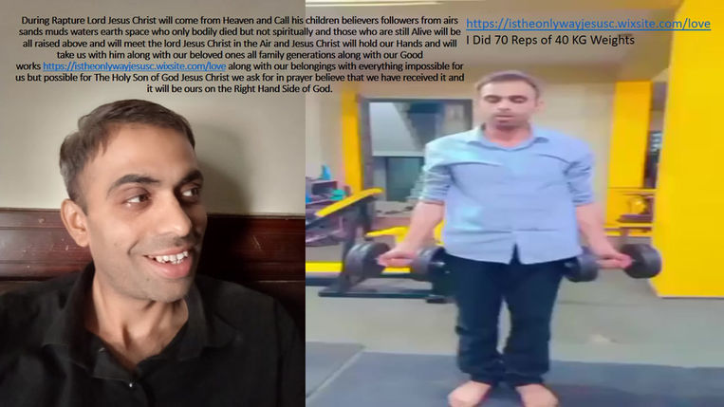

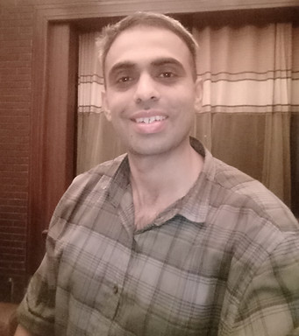

[](https://b8711c73-f667-413d-ad4f-e2588ecbc50e.filesusr.com/ugd/c98d81_86d1bd7b9cad4b35b276c432dd7ec464.pdf)



[408 SERVING OFFICER PAUL](https://b8711c73-f667-413d-ad4f-e2588ecbc50e.filesusr.com/ugd/c98d81_86d1bd7b9cad4b35b276c432dd7ec464.pdf" \t "_blank)

[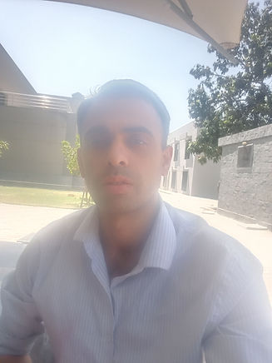](https://b8711c73-f667-413d-ad4f-e2588ecbc50e.filesusr.com/ugd/c98d81_d6ac7ee439814285a8a06507307f5847.docx?dn=Pakistan%20Army%20408%20Intelligence%20Battalion.docx)

[](https://b8711c73-f667-413d-ad4f-e2588ecbc50e.filesusr.com/ugd/c98d81_86d1bd7b9cad4b35b276c432dd7ec464.pdf)

[](https://b8711c73-f667-413d-ad4f-e2588ecbc50e.filesusr.com/ugd/c98d81_86d1bd7b9cad4b35b276c432dd7ec464.pdf)

[CURRENT CHIEF OF ARMY STAFF MAJOR GENERAL PAUL ELIYA PA#2638 SERVING IN UNIFORM](https://b8711c73-f667-413d-ad4f-e2588ecbc50e.filesusr.com/ugd/c98d81_86d1bd7b9cad4b35b276c432dd7ec464.pdf" \t "_blank)

[408 INTELLIGENCE BATTALION GHQ PAKISTAN](https://b8711c73-f667-413d-ad4f-e2588ecbc50e.filesusr.com/ugd/c98d81_86d1bd7b9cad4b35b276c432dd7ec464.pdf" \t "_blank)

[+](https://b8711c73-f667-413d-ad4f-e2588ecbc50e.filesusr.com/ugd/ab9c7d_2fcbf008d7474130a33d51ab0b2ab77a.xlsx?dn=FIRST%20TALENT%20OF%20INDIA.xlsx" \t "_blank)

[1](https://b8711c73-f667-413d-ad4f-e2588ecbc50e.filesusr.com/ugd/ab9c7d_ce45ae5d1761435193625ff534ec7320.pdf" \t "_blank)

[-](https://b8711c73-f667-413d-ad4f-e2588ecbc50e.filesusr.com/ugd/ab9c7d_b1ba954d93924738937608afe63debbe.pdf" \t "_blank)

[4](https://b8711c73-f667-413d-ad4f-e2588ecbc50e.filesusr.com/ugd/ab9c7d_7aebce1e198e49d78bfeee8272343be5.pdf" \t "_blank)

[.](https://b8711c73-f667-413d-ad4f-e2588ecbc50e.filesusr.com/ugd/c98d81_9393185b22e24a7f99fe35bb93ee1c12.pdf" \t "_blank)

[7](https://b8711c73-f667-413d-ad4f-e2588ecbc50e.filesusr.com/ugd/ab9c7d_4b6504d0aa9844d39e4a65b80e415b18.pdf" \t "_blank)

[N\*10^N](https://b8711c73-f667-413d-ad4f-e2588ecbc50e.filesusr.com/ugd/c98d81_e800c7a6f39c401fadc0181828dce542.docx?dn=JESUS%20CHRIST%20IS%20THE%20ONLY%20WAY.docx" \t "_blank)

[2](https://b8711c73-f667-413d-ad4f-e2588ecbc50e.filesusr.com/ugd/ab9c7d_1533a51f8c5b49f39c84a3f40daf2717.pdf" \t "_blank)

[5](https://b8711c73-f667-413d-ad4f-e2588ecbc50e.filesusr.com/ugd/ab9c7d_85c2926786ed4402ba60d1dc0e657c15.pdf" \t "_blank)

[8](https://b8711c73-f667-413d-ad4f-e2588ecbc50e.filesusr.com/ugd/ab9c7d_cc1f09df178f45c39bc6112b2a5de78b.pdf" \t "_blank)

[0](https://b8711c73-f667-413d-ad4f-e2588ecbc50e.filesusr.com/ugd/c98d81_813bb0459ac042bdb30eeaf5402a7925.pdf" \t "_blank)

[3](https://b8711c73-f667-413d-ad4f-e2588ecbc50e.filesusr.com/ugd/ab9c7d_aec1f68145814f64a3b9ed4141fc836a.pdf" \t "_blank)

[\*](https://b8711c73-f667-413d-ad4f-e2588ecbc50e.filesusr.com/ugd/ab9c7d_c7c0a2bc3aea48a2a6a5b448781a912b.pdf" \t "_blank)

[6](https://b8711c73-f667-413d-ad4f-e2588ecbc50e.filesusr.com/ugd/ab9c7d_34cccc067bf24fa0bc2ee087e6b77208.docx?dn=NINTH%20TALENT%20OF%20INDIA.docx" \t "_blank)

[/](https://b8711c73-f667-413d-ad4f-e2588ecbc50e.filesusr.com/ugd/ab9c7d_28feafa3a8d845cd9cdc73ff6471104d.pdf" \t "_blank)

[9](https://b8711c73-f667-413d-ad4f-e2588ecbc50e.filesusr.com/ugd/ab9c7d_082c7b1bbca640978a20855457caef09.docx?dn=FIGHTER%20PILOT%20PAUL%20ELIYA.docx" \t "_blank)

[AP](https://b8711c73-f667-413d-ad4f-e2588ecbc50e.filesusr.com/ugd/c98d81_8daea166ab63443da7c6700311b64ef8.docx?dn=BLASPHEMY%20CASE.docx" \t "_blank)

[NS](https://b8711c73-f667-413d-ad4f-e2588ecbc50e.filesusr.com/ugd/ab9c7d_efb95ed7bce44a048076027904b45abb.pdf" \t "_blank)

[EW](https://b8711c73-f667-413d-ad4f-e2588ecbc50e.filesusr.com/ugd/ab9c7d_efb95ed7bce44a048076027904b45abb.pdf" \t "_blank)

[HERO](https://b8711c73-f667-413d-ad4f-e2588ecbc50e.filesusr.com/ugd/c98d81_79352ed3565d40e8850fdfdd4edda277.pdf" \t "_blank)

[LOVE](https://b8711c73-f667-413d-ad4f-e2588ecbc50e.filesusr.com/ugd/c98d81_b3ca59d7398c4a50b3c8d569d78c81b9.docx?dn=HOPE.docx" \t "_blank)

[Explore](https://b8711c73-f667-413d-ad4f-e2588ecbc50e.filesusr.com/ugd/c98d81_79352ed3565d40e8850fdfdd4edda277.pdf" \t "_blank)

[SYED ALI ABBAS](https://b8711c73-f667-413d-ad4f-e2588ecbc50e.filesusr.com/ugd/c98d81_76d602d320d54fc2b4ccf5d737bbbe4d.docx?dn=NEW%20JERUSALEM.docx" \t "_blank)

[007 MI7](https://b8711c73-f667-413d-ad4f-e2588ecbc50e.filesusr.com/ugd/c98d81_43a4c494b49d4a54928df657891094a1.pdf" \t "_blank)

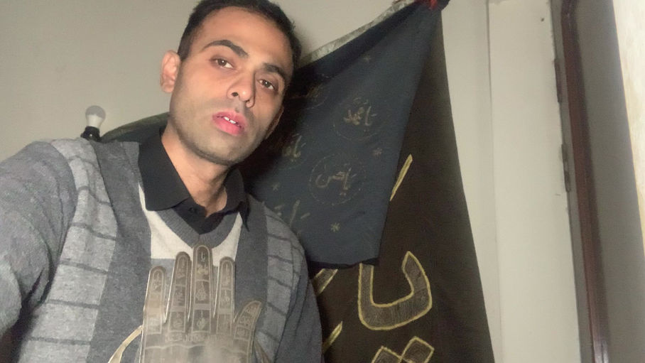



**[MY SANGJANI LAND 10 KANALS](https://b8711c73-f667-413d-ad4f-e2588ecbc50e.filesusr.com/ugd/c98d81_8456dc34e2bf44ceb4a2ac76c4353c1f.pdf" \t "_blank)**

**"Behold, I am coming quickly! Hold fast what you have, that no one may take your crown."**

**ALL MY GOOD WORKS**[**https://istheonlywayjesusc.wixsite.com/love**](https://istheonlywayjesusc.wixsite.com/love)**PRINTED OUT ON PHYSICAL PAPERS AND IN MEMORY CARDS CAPACITORS USB HARD DRIVES AND IN THE FORM OF ELECTROMAGNETIC FREQUENCIES VIBRATIONS WAVES AS RADIO SIGNALS MASS ENERGIES ARE SAVED IN JESUS CHRIST WILL BE SAVED BY JESUS CHRIST IN THE MUSEUM OF HEAVENLY NEW JERUSALEM, HE MADE ME SEE HEAVENS ORANGE PINKISH WHITE COLORFUL PLASMIC MATTERS OF UNIVERSES ALONG WITH MY BELOVED AND ALONG WITH MY BELONGINGS DURING RAPTURE RAISED ON THE RIGHT HAND SIDE OF GOD I BELIEVED THAT I HAVE RECEIVED IT AND IT WILL BE MINE I HOPE IN LOVE AND FAITH AS PROMISED BY THE ONLY HOLY SON OF GOD JESUS CHRIST PHYSICALLY ETERNALLY HEAVENLY IN IMMORTALITY RAISED RESURRECTED INCARNATED**

**because me and my family are PUSHED too far**[**https://youtube.com/shorts/zswZRCC\_ID8?si=bn7zfkdFjfoF2w-W**](https://youtube.com/shorts/zswZRCC_ID8?si=bn7zfkdFjfoF2w-W)[**https://istheonlywayjesusc.wixsite.com/Pakistan-army-church**](https://istheonlywayjesusc.wixsite.com/Pakistan-army-church)

**IF MY BELOVED MEMORIES ARE PHYSICAL SO MY DREAMS ETERNAL LIFE IS ALSO PHYSICAL**

**Dear Clayton I am Paul Eliya and I thank you to teach me to follow Christ The Holy Son of God. Please pray for me and for my family to survive in Pakistan and our immediate travel to the land where we will be free to worship Jesus Christ and we will love serve Jesus Christ and his children and his people and his followers unconditionally.Please Pray for me and for my family, we need your prayers as we are also praying for you all, I WILL USE TIK TOK TO EARN SOME MONEY BECAUSE I AM THE TALENTED SOUL SON OF MY ONLY SAVIOUR HOLY FATHER JESUS CHRIST ONLY, BECAUSE THE ONLY WAY TRUTH AND THE ETERNAL LIFE GOOD WORK OF HOLY FATHER SON AND SOUL OF GOD JESUS CHRIST TOOK THE FORGIVABLE SIN OF ADAM AND EVE ON HIM AND JESUS ONLY PUNISHES THOSE PEOPLE WHO EXCEEDS THE LIMITATIONS OF FORGIVEABLE SINS AND COMMITS UNFORGIVABLE SINS, THE LORD JESUS CHRIST IS THE BALANCE OF JUSTICE IN THE SOUL OF EVERY HUMAN BEING SEALED BETWEEN HEAVEN AND HELL WITH COURAGE AND KNOWLEDGE WITH BELONGINGS AND GOOD WORKS WITH BELOVED ONES FOREVER**[**https://istheonlywayjesusc.wixsite.com/ibne-baap-ali-mola**](https://istheonlywayjesusc.wixsite.com/ibne-baap-ali-mola)

**This is my story MY JOB IS DONE I SHOULD HAVE DIED BUT I AM STILL ALIVE FOR MY BELOVED ONES I AM LIVING WITH THEM ETERNALLY FOREVER IN THE DREAMS OF MY CHILDHOOD**

**THE HONOURABLE SHO THANA SADDAR BERUNI PUNJAB POLICE RAWALPINDI PAKISTAN.MY NAME IS PAUL ELIYA SON OF AMBEREEN FATIMA, ME AND MY FAMILY OF 7 EXTREMELY VULNERABLE HAVE BEEN FACING PERSECUTION SINCE 18 YEARS IN PAKISTAN, CURRENTLY WE ARE LIVING AS HOMELESS JOBLESS PERSONS OUR FUNDAMENTAL HUMAN RIGHTS HAVE BEEN FORCIBLY SNATCHED AND WE ARE STILL DEPRIVED FROM OUR BASIC FUNDAMENTAL HUMAN RIGHTS TO LIVE WITH DIGNITY, EQUALITY AND PEACE BUT IN YEAR 2013 I DID NOT COMMIT ANY BLASPHEMY NOR I DESECRATED HOLY QURAN BUT I WAS BEING ACCUSED OF DOING COMMITTING BLASPHEMY FOR BURNING AND DESECRATION OF THE HOLY QURAN AND AGAINST THE HOLY PROPHET MUHAMMAD PBUH AND MADRASA AHLE MOHALLA MASJID MOB GATHERED OUTSIDE MY HOME CHURCH 39 MARLAS DOUBLE STORY BUILDING # 25-A CB-3650 LANE 5-A LALAZAR COLONY TULSA ROAD FOR CARRYING OUT MY LYNCHING PUBLICALLY AND MADRASA MOSQUE AND NEIGHBOURS THE ACCUSED ABDUL QUDOOS, ABDUL RAUF AND RELATIVES VERBALLY CHARGED ME u/s 154 crPC u/s 295-A, 295-B and 295-C WITH THE ULTIMATE SUPPORT OF STATE AUTHORITIES AND THEY FRAMED ME AND MY FAMILY AS MAD PERSONS PSYCHO MENTALLY DISTURBED UNSTABLE PERSONS HAVING DANGEROUS THOUGHTS INTENTIONS AND CAPABILITIES, ME AND MY PARENTS WERE FORCED TO GIVE THE PROPERTY AT LOW PRICE TO ACCUSED RAJA AMJAD IQBAL ABBASI OTHERWISE IF WE DO NOT SIGN AND THUMB IMPRESSION THE SALE DEED TRANSFER OF PROPERTY PAPERS THEY WOULD HAVE KILLED ME AND MY FAMILY EITHER THROUGH UNKNOWN ENTITIES THROUGH AN ACCIDENT OR PUBLICALLY BUT WE FOUGHT BACK AND FACED MORE PERSECUTION AND SHIFTED 24 HOUSES IN 12 YEARS TIME SPAN FROM YEAR 2014 TILL NOW, ALL THE EVIDENCES ARE IN THIS WEBSITE**[**https://istheonlywayjesusc.wixsite.com/love**](https://istheonlywayjesusc.wixsite.com/love)**I WANT THE REPOSSESSION OF MY PROPERTY BACK AND 10 KANALS SANGJANI LAND POLICE STATION TARNOL 808-5-A 17-12-2020 THAT WAS ALSO FRAUDULENTLY TAKEN BY MY RELATIVES IN YEAR 2004 AND ME AND MY MOTHER WAS LOCKED UP IN POLICE STATION KOHSAR ISLAMABAD JINNAH SUPER AND IN WOMEN POLICE STATION G-7 ON 17-02-2021 AND WE WERE BEING TORTURED MENTALLY PHYSICALLY BY POLITICAL PARTIES AND I WAS GIVEN POISON TWICE TO MURDER ME AND ISIS TERRORISTS IN ISLAMABAD POLICE UNIFORMS IN PAKISTAN PUT THEIR REVOLVER ON MY HEAD TO SHOOT ME INSIDE LOCKUP BUT ISLAMABAD POLICE RELEASED US OUTSIDE CHIEF COMMISSIONER OFFICE G-11 G-10 ISLAMABAD AND THEY ALSO THREATENED ME AND MY FAMILY NOT TO PROTEST FOR TAKING BACK OUR PROPERTY AND FUNDAMENTAL HUMAN RIGHTS AND THEY TOLD US THAT THEY WILL KILL US IF WE TRY TO DISCLOSE OUR BLASPHEMY CASE IN PUBLIC OR IN ANY COURT OF PAKISTAN AND THEY ALSO DECLARED US ME AND MY FAMILY AS TRAITORS HAVING LINKS WITH THE ENEMIES OF PAKISTAN DETAILS ARE IN MY WEBSITE, AND MY LAND 10 KANALS THAT WAS ALSO FRAUDULENTLY TAKEN BY MY RELATIVES BY MISINFORMATION GIVEN TO MY MOTHER THAT SHE WAS SELLING ONLY ONE KANAL LAND BUT MY HER RELATIVES TRANSFERED ALL 10 KANALS IN YEAR 2004 BECAUSE ME AND MY FAMILY WERE CONVERTED TO CHRISTIANITY IN YEAR 2000 AND WE WERE LEGALLY BAPTIZED IN YEAR 2015. PAKISTAN ARMY HELP CENTRE IS DEALING WITH THIS CASE BUT DELAYING IN GIVING JUSTICE TO US, ON ACCOUNT OF OUR SUFFERINGS TROUBLES SORROWS PAIN AND ANGUISH ME AND MY FAMILY WANT TO MOVE TO ANY CHRISTIAN COUNTRY TO SAVE OUR LIVES, WE ALSO WANT FINANCIAL SUPPORT TO SURVIVE BECAUSE NO ONE GIVES ME JOB NO NGO NO COUNSEL NO ATTORNEY NO LAWYER IS NO LONGER INTERESTED IN FIGHTING MY CASE REPRESENTING MY CASE IN BEFORE ANY COURT OF LAW OF PAKISTAN ULTIMATELY RESULTING NON-PROSECUTION, PLEASE ARREST RAJA AMJAD IQBAL ABBASI, ABDUL QUDOOS AND ABDUL RAUF ALONG WITH OTHERS. ME AND MY FAMILY HAVE BEEN INTERNALLY DISPLACED PERSONS SINCE AUGUST 2014 DUE TO PERSECUTION, WE WANT**

**OUR FUNDAMENTAL HUMAN RIGHTS TO GET JUSTICE FROM THIS POLICE STATION THANA SADDAR BERUNI RAWALPINDI. Regards PASTOR PAUL ELIYA AND CATHOLIC CHRISTIAN FAMILY CNIC:37405-0365980-9 PASSPORT# LL1019803 HOUSE#96, LANE#4, BLOCK D, SECTOR 4 AIRPORT HOUSING SOCIETY RAWALPINDI CANTT 03145550432, 03185309511**

SOME USEFUL LINKS

[**https://www.usembassy.gov/**](https://www.usembassy.gov/)

[**https://pk.usembassy.gov/**](https://pk.usembassy.gov/)

[**https://www.uscis.gov/**](https://www.uscis.gov/)

[**https://www.fbi.gov/contact-us/fbi-headquarters**](https://www.fbi.gov/contact-us/fbi-headquarters)

[**https://www.whitehouse.gov/contact/**](https://www.whitehouse.gov/contact/)

[**https://www.cia.gov/contact-cia/**](https://www.cia.gov/contact-cia/)

Save